**JQuery Basic, Effects & Advanced**

1. **What is jQuery?**

--> JQuery is a fast and feature-rich JavaScript library that simplifies web development by providing a concise and consistent way to interact with HTML documents, handle events, perform animations.

1. **How to Apply CSS Using JQuery, How to Add Class and Remove Class in Jquery, JQuery Animation?**

--> Applying CSS using JQuery:

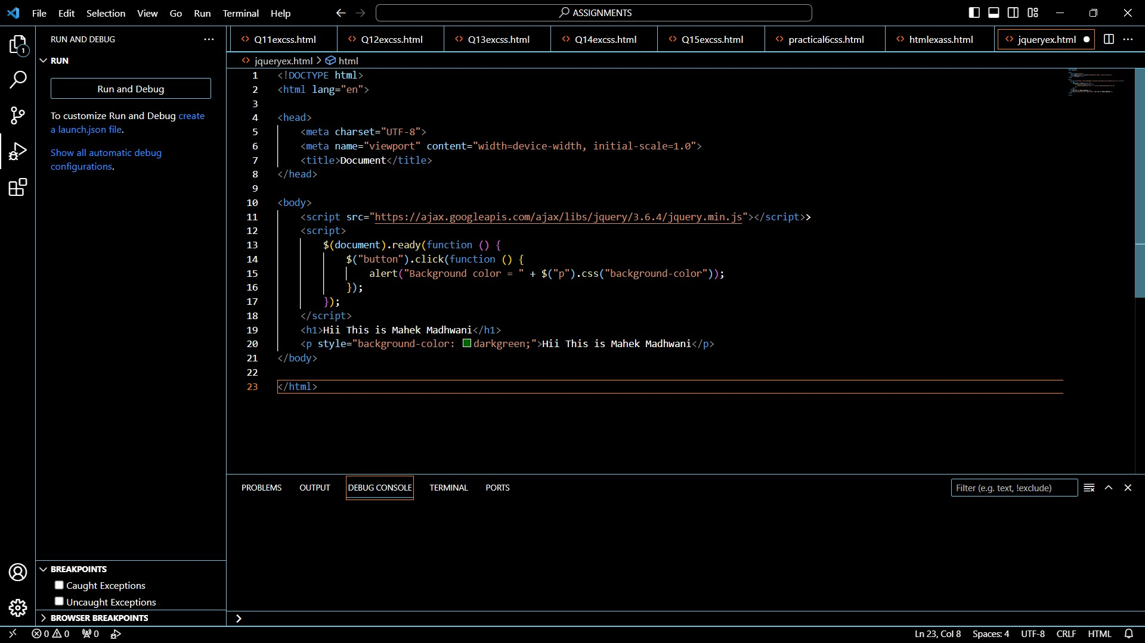

**OUTPUT:**



--> Adding and Removing class in jquery:

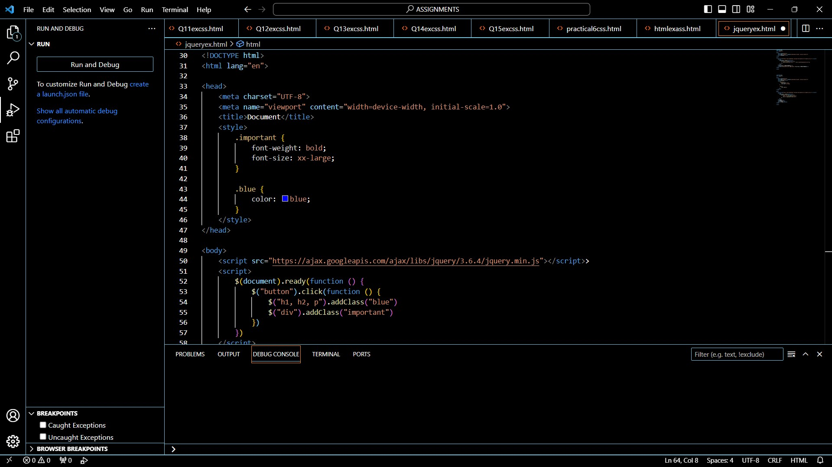

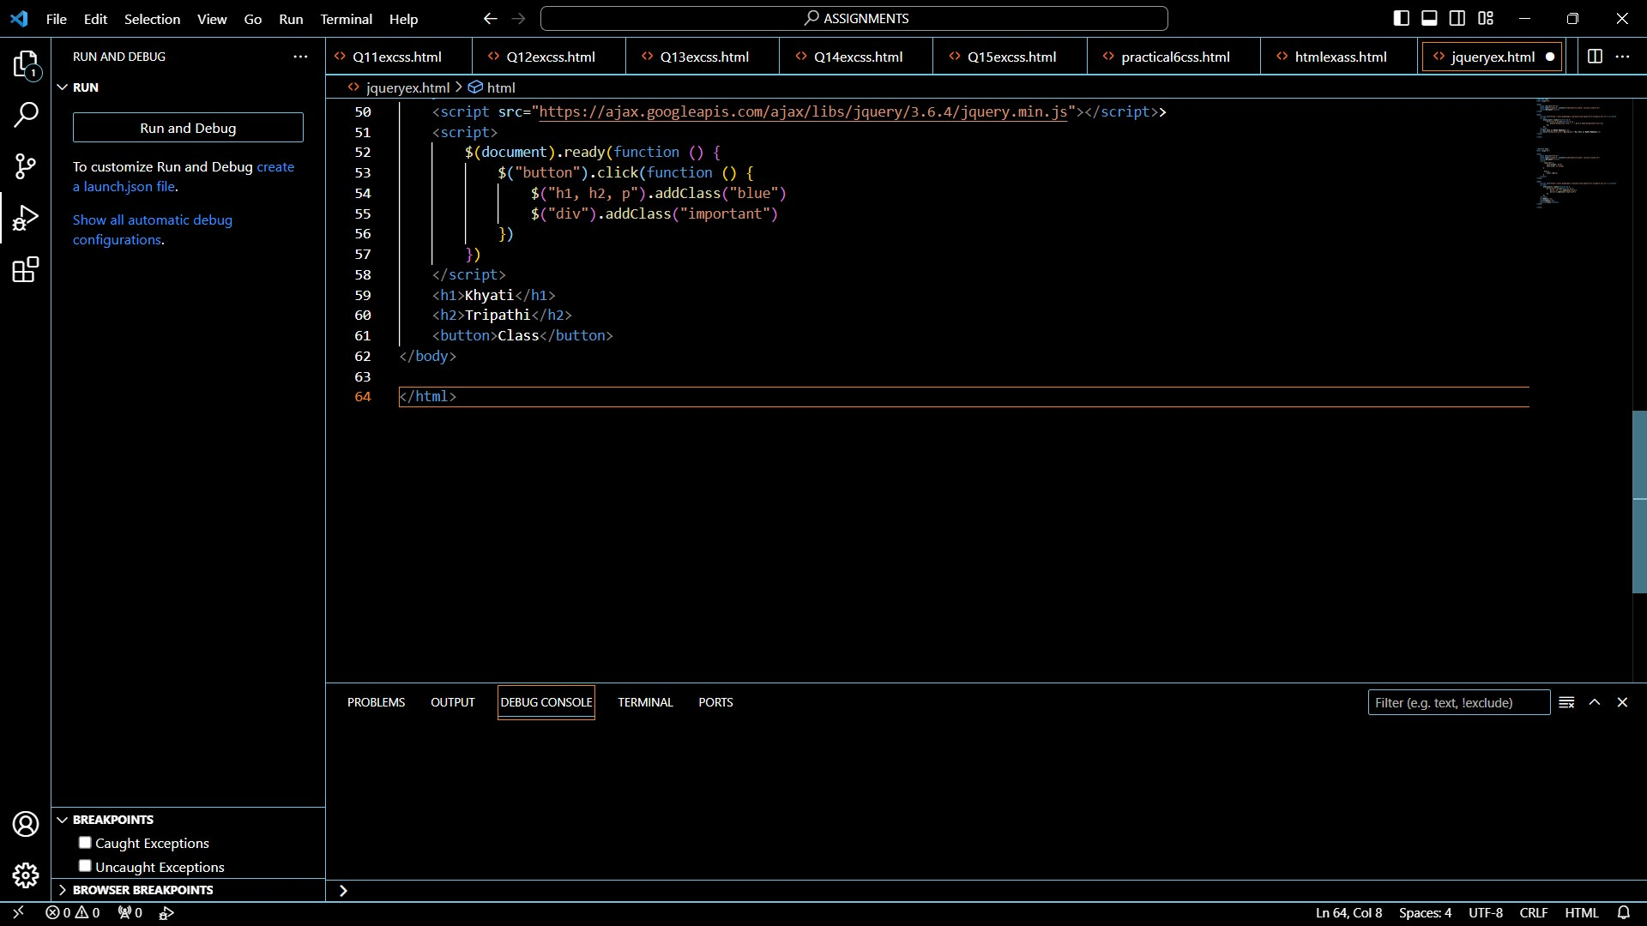

--> For jquery animation:

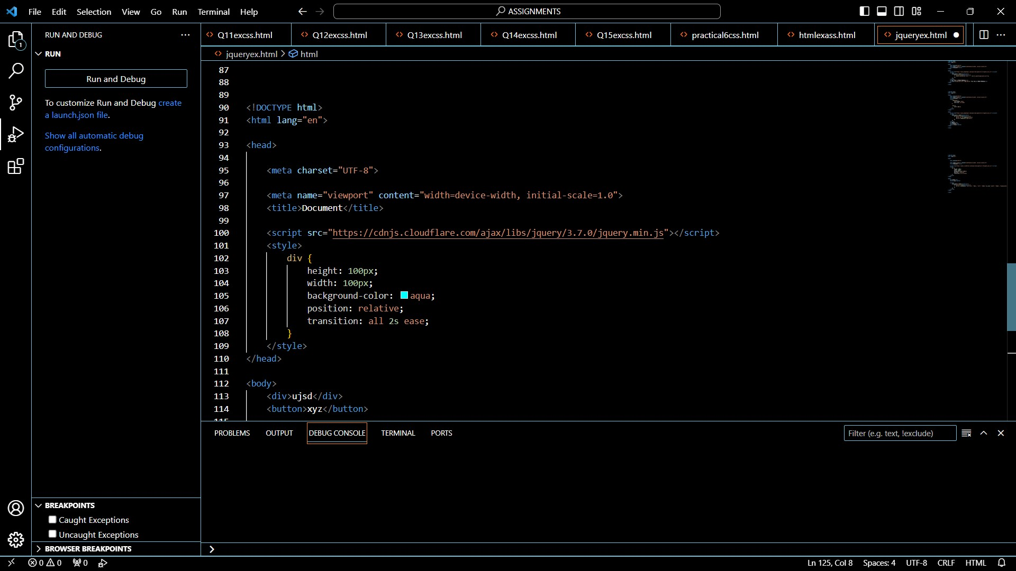

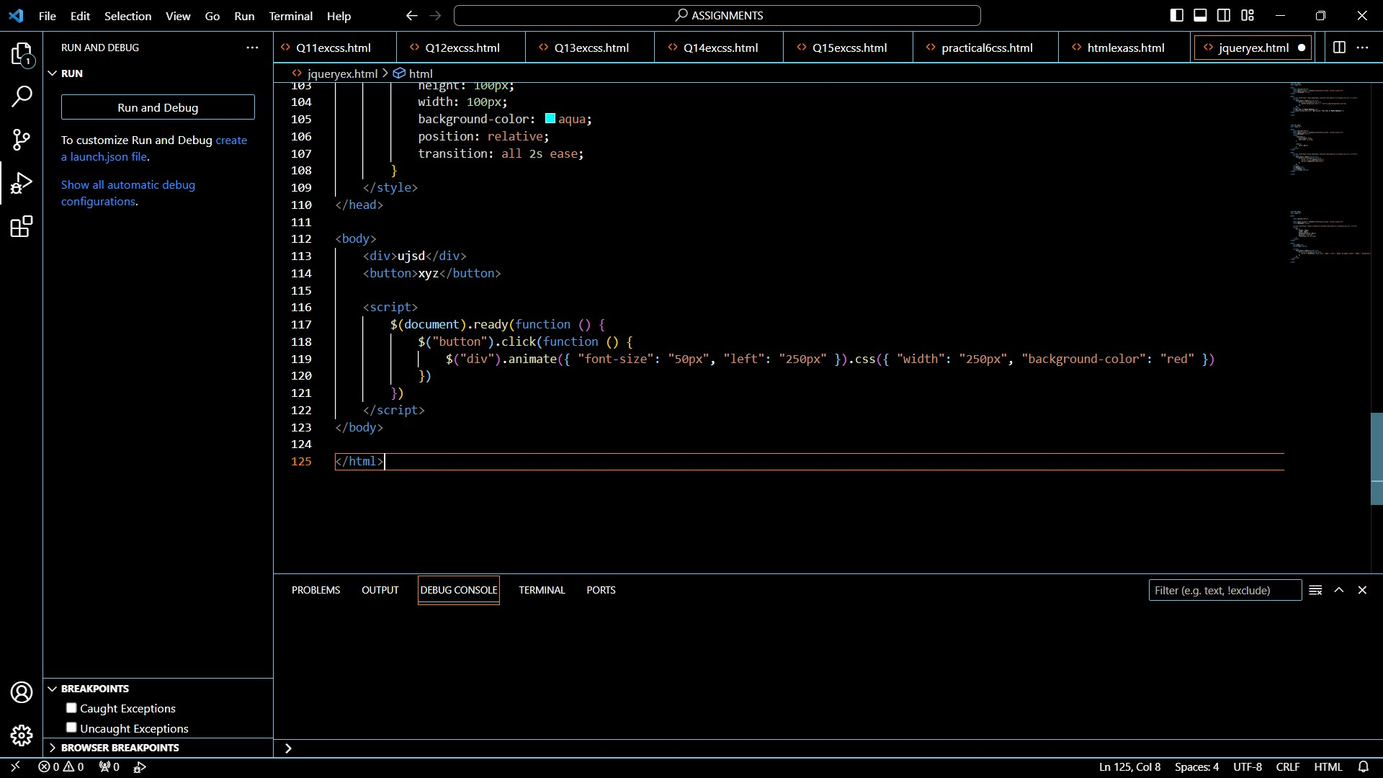

1. **How to create slider with animation?**

-->

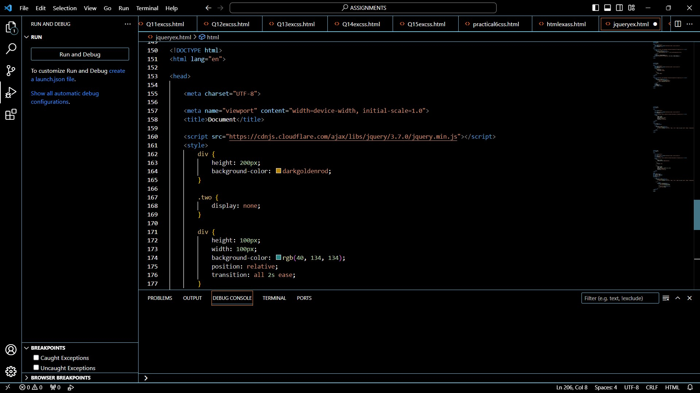

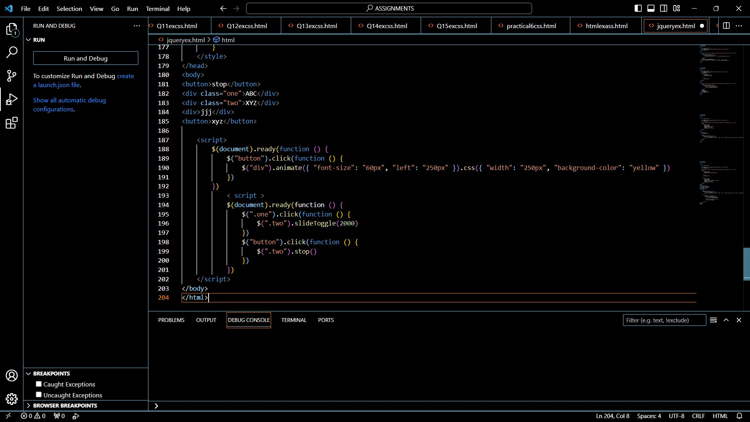

1. **Event bubbling tickling example**



